PRACTICAL-3: **CRUD USING Mogodb**

Date:-10/01/2025 Submission Date:- 17/01/2025

Write-up: -

· NOSQL Vs SQL

· Types of NOSQL

· Document document-oriented NoSQL

· Mangodb

· Mangodb shell

· Basic commands of mangodb

1. Install

<https://www.mongodb.com/try/download/compass>

2. set environment variable

3. Install mangodb shell

<https://www.mongodb.com/try/download/shell>

**Performing CRUD Operations in MongoDB:**

Creating a New Database:



Creating a New Collection:

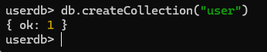

Create Operation:

1.insertOne():

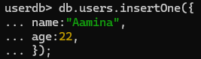

Output:

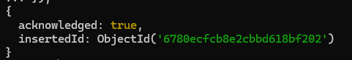

2.insertMany():



Output:

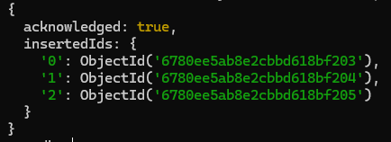

Read Operations:

1. find()

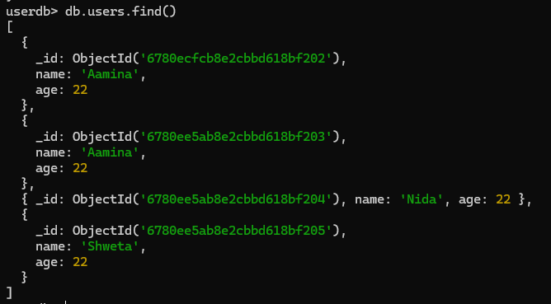

2.findOne()



Output:



Update Operations:

1. updateOne():



Output:

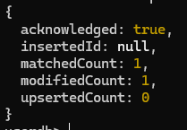

1. updateMany():



Output:

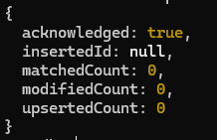

Delete Operation: In MongoDB, the "delete" operation is used to remove documents from a collection.

There are several ways to perform a delete operation, including the following:

1.deleteOne()”



Output:



2.deleteMany():



Output:



1. drop():

The drop() method is used to remove an entire collection.

